

Emerson Launches Innovative Software-Driven Method for High-Fidelity Aerospace RF Testing
NI CHESS enables flexible software-driven, lab-based RF validation to reduce costs and risks of field testing
AUSTIN, Texas (April 13, 2026) – Emerson announced the NI Channel Emulator System Software (CHESS) platform today at the 2026 Space Symposium conference in Colorado, introducing a new software‑defined approach that enables aerospace and defense teams to validate mission‑critical radio frequency (RF) links entirely in the lab—without the cost, risk or logistics of traditional field testing.
NI CHESS is a high‑fidelity RF channel emulation platform that works with NI PXI Vector Signal Transceiver (VST) hardware to recreate realistic, dynamic RF environments in real time. Purpose‑built for aerospace, satellite and defense communication systems, the platform allows engineers to test complex ground‑to‑orbit, ground‑to‑air and airborne links under controlled, repeatable conditions.
By combining model‑based simulation with hardware‑in‑the‑loop execution, NI CHESS streams real‑time RF impairments—including Doppler shift, multipath fading, path loss and interference—through high‑speed FPGA co‑processing and third‑party scenario tools. This enables teams to uncover issues sooner, achieve mission readiness faster, and significantly reduce reliance on late stage field testing by enabling earlier issue detection and repeatable validation in the lab, helping teams avoid the logistical burden, rework and delays common in field based test campaigns.

Unlike traditional test methods constrained by simplified channel approximations, NI CHESS delivers realistic RF behavior emulation and adapts as systems grow in complexity. Its multi‑channel, wideband architecture supports advanced aerospace and satellite systems without requiring redesign of existing test setups.
“Modern aerospace communication systems are becoming more complex, while field testing is increasingly expensive and constrained. NI CHESS gives engineers a practical way to validate mission‑critical RF performance early and often using true‑to‑life conditions in the lab so teams can move faster, reduce risk and control costs without compromising realism,” said Chris Behnke, director for aerospace and defense RF test and validation systems at Emerson.
Because NI CHESS is software‑based and integrates directly with existing NI PXI RF infrastructure, teams can deploy it quickly and extend the value of their current lab investments while expanding test coverage and capability.
NI CHESS is available now as part of Emerson’s NI portfolio. To learn more about the NI Channel Emulator System Software and how it can help move RF testing from the field into the lab, visit www.ni.com/CHESS.
# # #

About Emerson
Emerson (NYSE: EMR) is a global automation leader delivering solutions for the most demanding technology challenges. Headquartered in St. Louis, Missouri, Emerson is engineering the autonomous future, enabling customers to optimize operations and accelerate innovation. For more information, visit Emerson.com.
Media Contact
Contacts: Emerson Global Media Contacts

Contact: Katie Willem
Katie.Willem@emerson.com

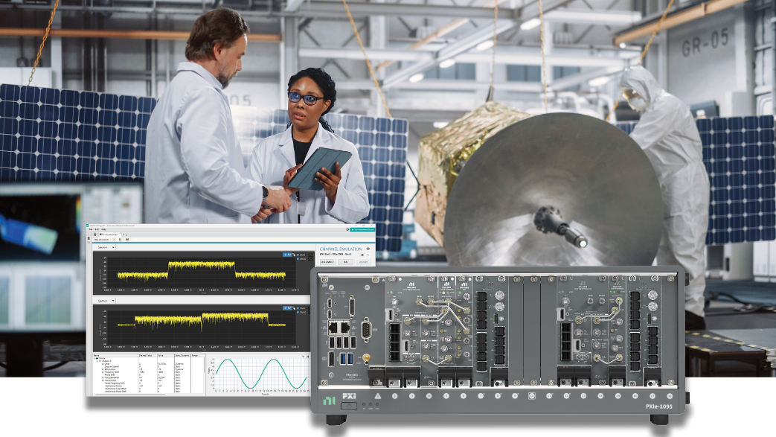
With Emerson’s Channel Emulator System Software (CHESS) platform, RF test systems can simulate real‑world satellite channels in the lab, enabling faster validation and integration.

