

Emerson Broadens Access to Modular Test Platform with Cost-Effective Automation Hardware
New NI PXI options build on 25 years of test expertise to accelerate system development, streamline integration and boost engineers’ future readiness

AUSTIN, Texas (Jan. 20, 2026) – Emerson is expanding access to its field-proven NI PXI test platform with new high-performance hardware at a more affordable price point. These additions make it easier for more engineering teams to adopt scalable, low-cost automated test systems without compromising precision or reliability, while laying the groundwork for AI-enhanced workflows.
The new NI PXI hardware—including high-resolution oscilloscopes, multifunction I/O modules, embedded controllers and an all-hybrid chassis—maintains the NI brand’s hallmark strengths in software integration, synchronized measurements and high channel density, while lowering the cost barrier for test system development. Combined with powerful NI software ecosystems like LabVIEWTM, InstrumentStudioTM and TestStandTM, Emerson empowers test teams to accelerate automation, simplify integration and build future-ready test solutions that evolve with their needs.
By lowering the cost barrier, Emerson is opening the NI Platform to smaller teams and emerging industries. The new, affordable NI PXI products include:

- High-resolution oscilloscopes (NI PXIe-5108): Four- and eight-channel options with 100-megahertz bandwidth, 250-MegaSample per second sample rate and 14-bit resolution. The flexible, high-density design means engineers capture more data, faster, with seamless precision.
- 18-slot hybrid chassis (NI PXIe-1081): An all-hybrid chassis with 2 gigabits per second system bandwidth. Built for growth, it scales easily and connects software-driven test systems so more teams can access critical data.
- Embedded controllers (NI PXIe-8842 / 8862): Simplified controllers supporting Windows 11™ and NI Linux Real-Time™. Engineering teams that don’t need a general purpose interface bus (GPIB) can ensure more accurate and efficient measurements in their workstreams.
- 18-bit multifunction I/O modules (NI PXIe-6381 / 6383): New data acquisition (DAQ) modules offering industry-leading measurement performance with 18 bits of resolution and absolute accuracy down to 980 microvolts. With low noise voltage measurements across 16 or 32 channels, they deliver high accuracy and scalable solutions to automated test systems.

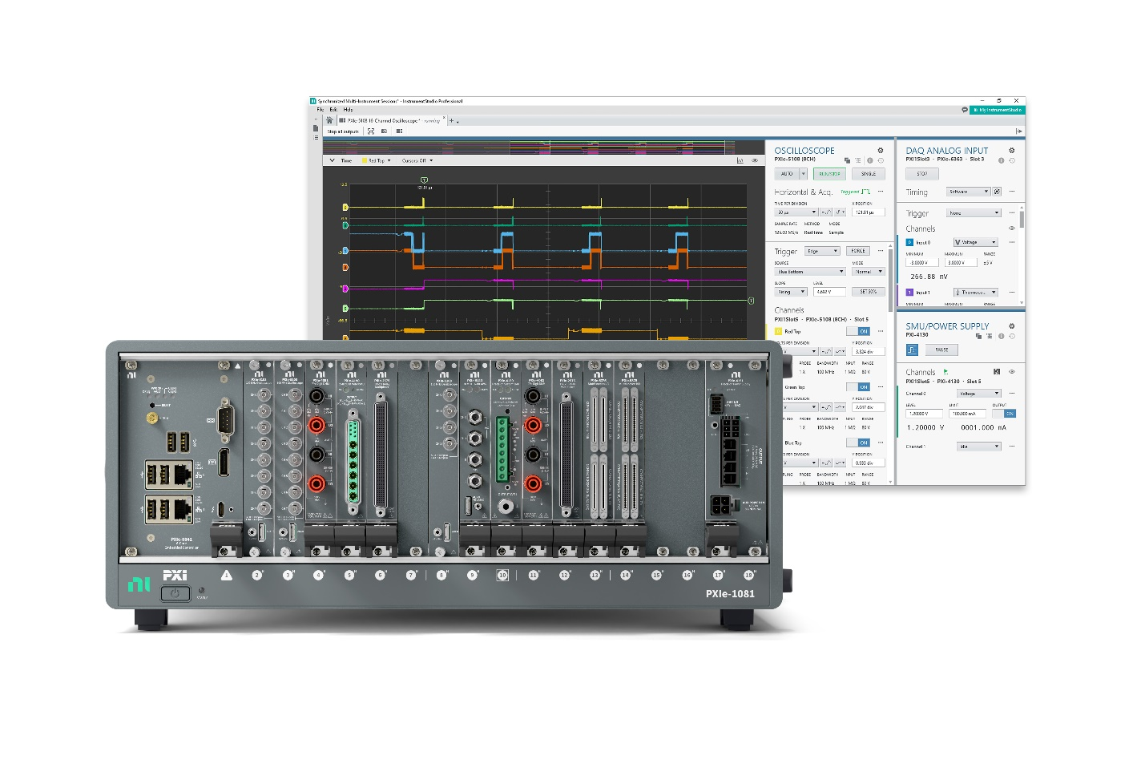
PXI-based test system featuring new NI PXIe-1081 chassis, NI PXIe-8842 embedded controller, and NI PXIe-5108 Oscilloscope for software-driven mixed-signal measurements with InstrumentStudio
These new products represent the building blocks of a complete PXI system, where the true power behind better test capability revolves around engineers’ access to modular and configurable systems to meet unique test and measurement needs.
"For 25 years, our modular NI PXI platform has empowered customers to future-proof their instrumentation investment through innovative upgrades that deliver the latest test and measurement capabilities. We’re excited that now more test engineers will be able to improve their workflows and increase their productivity through the NI platform with these new products,” said Charles Schroeder, NI fellow at Emerson’s test and measurement business.

“This foundational line of affordable, powerful NI PXI products allows test engineers to unlock deeper access to better data while making the right cost and performance trade-offs for their organization. It introduces the future of test and measurement and reimagines productivity in the age of AI.”
The current line of NI PXI products—with synchronized, high-density measurements and modular scalability—is uniquely positioned to support the use of AI for real-time reasoning and data insights within test environments.
To learn more about these new NI PXI products, join the NI webinar on January 21, 2026 titled, “Scope It Out: 4 New Affordable PXI Products.”
Windows 11 is a trademark of Microsoft Corporation.
Linux Real-Time is a trademark of Linus Torvalds.

# # #

Media:
- Contacts: Emerson Global Media Contacts
Additional resources:

- Join the Emerson Exchange 365 Community
- Connect with Emerson via X Facebook LinkedIn YouTube

About Emerson
Emerson (NYSE: EMR) is a global automation leader delivering solutions for the most demanding technology challenges. Headquartered in St. Louis, Missouri, Emerson is engineering the autonomous future, enabling customers to optimize operations and accelerate innovation. For more information, visit Emerson.com.

Contact:
Susanne Pastucha
Susanne.Pastucha@emerson.com

