Embargoed until February 24, 2026, 10 AM



Emerson Launches New Software Defined Radio for Radar, Satellite and 6G Research
NI USRP X420 combines 20-gigahertz frequency range and phase-coherent, multi-channel architecture to accelerate next-generation RF innovation

AUSTIN, Texas (Feb. 24, 2026) – Emerson today announced the launch of the NI USRP X420, a software defined radio (SDR) designed to meet the demanding requirements of advanced radar systems, satellite communications, and emerging 6G research.

The X420 expands the NI Universal Software Radio Peripheral (USRP) product line with frequency coverage up to 20 gigahertz. This opens access to higher-frequency spectrum including FR3, Ku, and X bands, supporting advanced applications such as multi-channel radar, non-terrestrial networks (NTN), and integrated sensing and communications (ISAC).

The X420 delivers near instrument-grade RF performance in a flexible, software-defined platform optimized for research, prototyping and deployment. By combining wide frequency coverage, high instantaneous bandwidth, and phase-coherent multi-channel operation, the X420 enables researchers and engineers to rapidly develop and validate complex RF systems across aerospace, defense, wireless communications and academic research environments.

Key features and benefits include:

- Extended frequency range up to 20 GHz: Supports advanced radar development, satellite communications, and 6G FR3 and NTN research.
- Phase-coherent multi-channel architecture: Integrated local oscillator (LO) sharing simplifies synchronization, reduces system complexity and accelerates development.
- High instantaneous bandwidth: Enables wideband signal capture and generation for applications such as spectrum monitoring, record and playback, and integrated sensing and communications.
- Accessible high-end RF capability: Brings cutting-edge performance to academic labs, government research organizations, and commercial innovators.
- Top-of-the-line USRP: Offers most advanced RF performance from Emerson’s USRP product portfolio to date.

The LO sharing feature is particularly significant for aerospace and defense applications, where phase coherence is critical for beamforming, MIMO radar, and distributed sensing architectures. By minimizing external synchronization hardware, the X420 enables faster prototyping, lower system cost and more scalable multi-channel designs.
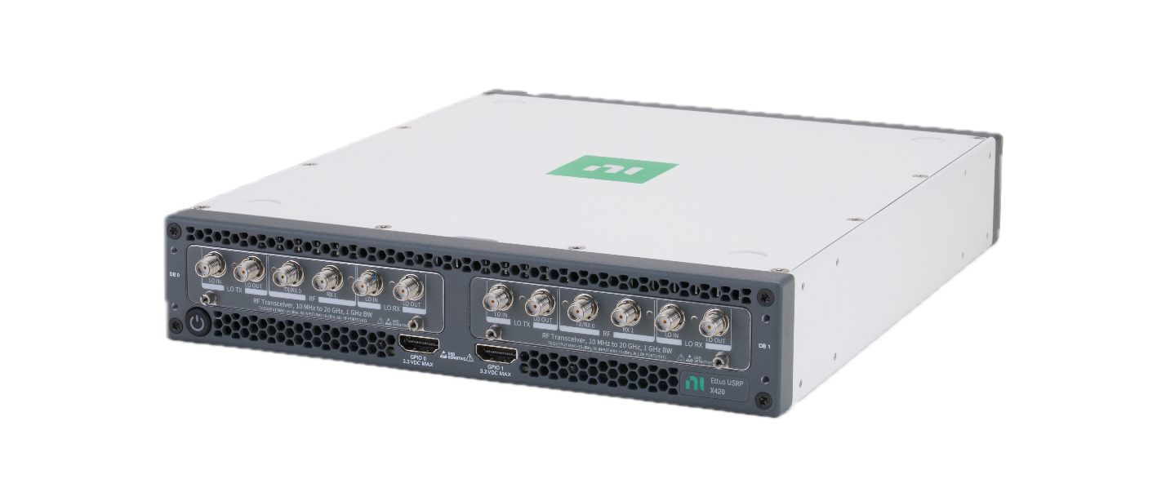
NI USRP X420 combines 20-gigahertz frequency range and phase-coherent, multi-channel architecture.

“Researchers need tools that combine flexibility with performance to keep pace with rapidly evolving technologies like 6G and advanced radar,” said Sarah LaSelva, chief product marketing manager for NI RF and wireless at Emerson. “The X420 delivers that balance by providing access to high-frequency spectrum and multi-channel coherence in a software-defined platform that accelerates innovation.”
For more information, visit the NI USRP X420 page on ni.com

# # #

Media:
- Contacts: Emerson Global Media Contacts
Additional resources:

- What Is a USRP Software Defined Radio Device?

About Emerson
Emerson (NYSE: EMR) is a global automation leader delivering solutions for the most demanding technology challenges. Headquartered in St. Louis, Missouri, Emerson is engineering the autonomous future, enabling customers to optimize operations and accelerate innovation. For more information, visit Emerson.com.

Contact:
Katie Willem
Katie.Willem@emerson.com

