

Emerson Reaches Milestone with Enhanced AI for Flagship
Test and Measurement Software Platform
NI LabVIEW+ Suite introduces code completion and other powerful capabilities to redefine test development productivity and efficiency in the age of AI

AUSTIN, Texas (Feb. 3, 2026) – Emerson today announced an updated version of NI Nigel™ AI, the industry’s first test-optimized AI technology, as well as new capabilities across its NI LabVIEW+ Suite. This iteration of Nigel AI introduces code completion and contextual awareness of test projects and local hardware to further accelerate test development. Nigel AI is available through the LabVIEW+ Suite, a complete set of purpose-built tools created to aid test engineers with built-in expertise at their fingertips.

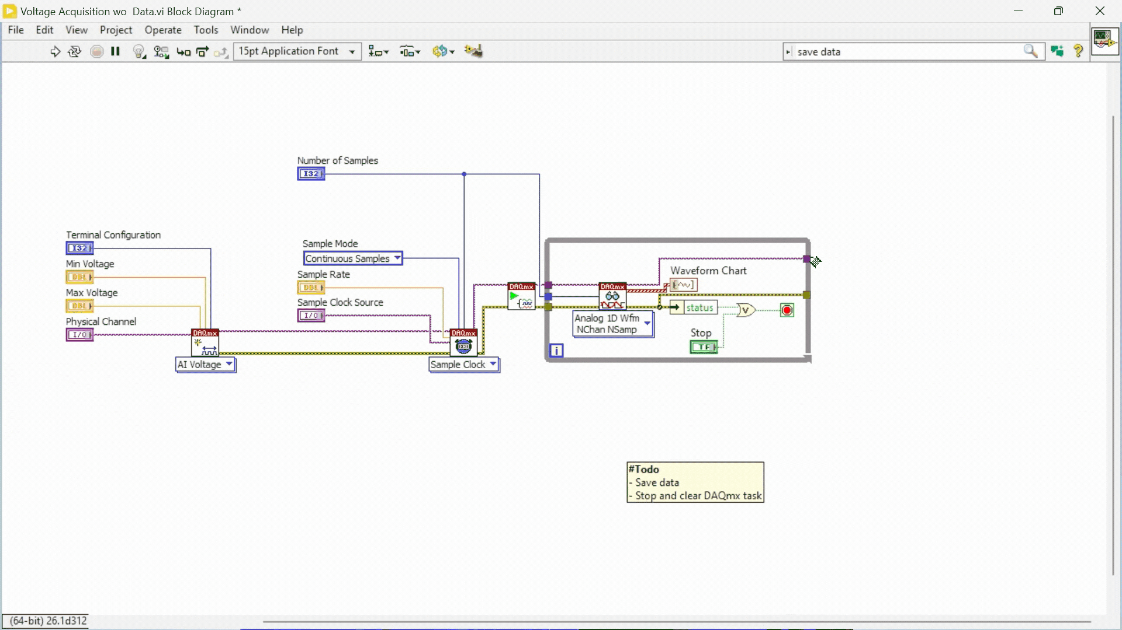
A demonstration of code completion in LabVIEW. Nigel recommends functions to complete a voltage measurement program in LabVIEW.

“We recognize that the role of an engineer is far more than just programming,” said Rudy Sengupta, vice president and general manager, NI test and analytics software, Emerson. “That’s why we created the LabVIEW+ Suite, to serve test professionals in a more comprehensive and intuitive way. The suite lets engineers carry context, configurations and data with them as they switch from task to task, saving significant time and empowering them to focus on the most valuable parts of their role."
The new technology reflects Emerson’s vision of reimagining productivity in the age of AI, empowering test engineers to keep pace with rising expectations for speed and efficiency while unlocking new levels of innovation through tools designed expressly for their work. This iteration builds on the initial release of Nigel AI last year with new capabilities. To better serve engineers, it has been taught test system design, test methodologies and test data analysis.

Nigel AI now has a code completion feature that suggests several intelligent next-step options during development, helping engineers select the best choice for their workflow while saving valuable programing time and avoiding potential errors. Nigel AI also gains contextual awareness of NI LabVIEW™ projects and the ability to review NI TestStand™ sequences and access local hardware, giving engineers context-rich support that accelerates development and improves accuracy.
Further enhancements to the LabVIEW+ Suite are designed to serve the large, global community of users with new features that enhance productivity and help to meet the most challenging test requirements. New features in this release include:

- Modern user interfaces leveraging new web technologies in LabVIEW and TestStand.
- Improved debugging workflows in LabVIEW with better source code control integration.
- Containerization through Docker Desktop™ support for Windows™ improving CI/CD pipelines.
- Installer enhancements for faster set-up.
Click here to learn more about AI for test and measurement technologies, and register here for the “Introducing LabVIEW+ Suite 2026 Q1 - Nigel AI Has Evolved” webinar on March 5, 2026.

Windows is a registered trademark of Microsoft Corporation.

Docker Desktop is a registered trademark of Docker, Inc.

# # #

Media:
- Contacts: Emerson Global Media Contacts
Additional resources:

- Join the Emerson Exchange 365 Community
- Connect with Emerson via X Facebook LinkedIn YouTube
About Emerson
Emerson (NYSE: EMR) is a global automation leader delivering solutions for the most demanding technology challenges. Headquartered in St. Louis, Missouri, Emerson is engineering the autonomous future, enabling customers to optimize operations and accelerate innovation. For more information, visit Emerson.com.
Contact: Katie Willem
Katie.Willem@emerson.com

