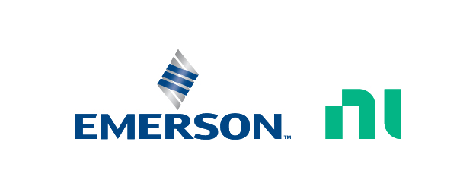 | Executive Bio

René Nuessgen
R&D Senior Director & Site Leader NI Dresden, NI Technology Innovation Office
Test & Measurement, Emerson

As an NI R&D Senior Director of Technology and Innovation, Rene Nuessgen works across the company on key business- and technology-driven initiatives in the AI Software and RF/Wireless space. In this role, he collaborates with executive leaders and department heads across marketing, sales, and R&D to drive NI’s technology and innovation strategy, supporting the development of groundbreaking solutions to complex test challenges.

Rene also contributes to initiatives within the NI Technology and Innovation Office, supporting broader efforts to drive long-term innovation and align technology development with evolving customer and market needs.

Before joining Emerson/NI in 2012, Rene held various engineering and leadership positions across multiple companies, focusing on RF/Wireless multi-mode connectivity, cellular chipset development and test, base station test, and semiconductor production test. Through these roles, he has built extensive expertise across the wireless ecosystem.

Rene holds a master’s degree in electrical engineering from the Technical University of Dresden

